Over the course of the project, the team has identified a different microcontroller from TI that will suffice to replace the MSP430F5529. Given some of the parameters that are critical to this data logging application, the team believes that the replacement will be an upgrade to the current microcontroller that we are using right now. The model of the new microcontroller is MSP432. Below are the pictures of the new microcontroller as well as the table comparing the specifications between the old and the new models.

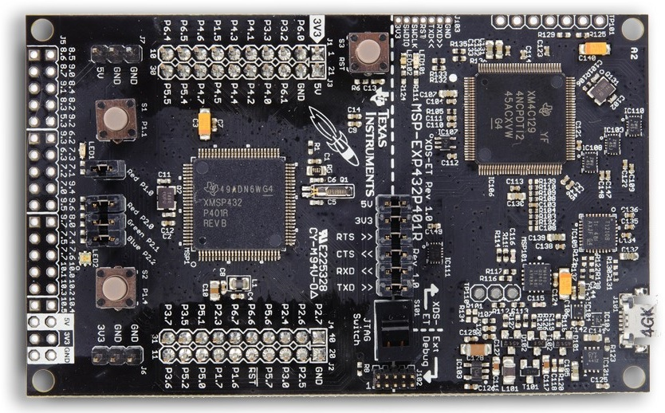

Figure 1. Picture of the new MSP432 from TI.

|  |  |  |
| --- | --- | --- |
|  | MSP430F5529 | MSP432 |
| CPU Clock Speed (MHz) | 25 | 48 |
| ADC Sampling Rate (kHz) | 200 | 1000 |
| ADC Resolution (bit) | 12 | 14 |
| Power in Active (uA/MHz) | 300 | 90 |
| Floating Point Unit Hardware | Not Supported | Supported |
| Deep Sleep Mode (nA) | 180 | 25 |
| RAM (kB) | 8 | 32 |
| Flash (kB) | 128 | 256 |
| Price ($) | 13 | 13 |

Table 1. Comparing parameters of interest between MSP430F5529 and MSP432.

As seen from above table, every parameters of interest in this application are better on the MSP432. For these reasons, we recommend that future design might use this new model instead of the MSP430F5529.